A Major Project Phase 2 On
GOOGLE PLAYSTORE APP RATING PREDICTION
Submitted in partial fulfillment of the requirements for the award of the

Bachelor of Technology
In

Department of Computer Science and Engineering

By
M SAI KIRAN | 18241A0527
M S KUSHAL RAJ | 18241A0526
P V S KARTHIKEYA | 17241A05S4
M VARUN TEJA | 18241A0529

Under the Esteemed guidance of
Dr B Srinivasa Rao,
Professor

Department of Computer Science and Engineering
GOKARAJU RANGARAJU INSTITUTE OF ENGINEERING AND TECHNOLOGY (Approved by AICTE, Autonomous under JNTUH, Hyderabad, Bachupally, Kukatpally, Hyderabad-500090



GOKARAJU RANGARAJU INSTITUTE OF ENGINEERING AND TECHNOLOGY (Approved by AICTE, Autonomous under JNTUH, Hyderabad, Bachupally, Kukatpally, Hyderabad-500090

CERTIFICATE

This is to certify that the major project entitled “Google Play Store App Rating Prediction” is submitted by M Sai Kiran(18241A0527), M S Kushal Raj(18241A0526), P V S Karthikeya(17241A05S4), M Varun Teja(18241A0529) in partial fulfillment of the award of degree in BACHELOR OF TECHNOLOGY in Computer Science and Engineering during academic year 2021-2022.

INTERNAL GUIDE HEAD OF THE DEPARTMENT
Dr B Srinivasa Rao Dr. K. MADHAVI
(Professor) (Professor)

EXTERNAL EXAMINER

ACKNOWLEDGEMENT

There are many people who helped us directly and indirectly to complete our project successfully. We would like to take this opportunity to thank one and all. First we would like to express our deep gratitude towards our internal guide Dr B Srinivasa Rao, Prof. Department of CSE for his support in the completion of our dissertation. We wish to express our sincere thanks to Dr. K. Madhavi, HOD, Department of CSE and to our principal Dr. J. Praveen for providing the facilities to complete the dissertation. We would like to thank all our faculty and friends for their help and constructive criticism during the project period. Finally, we are very much indebted to our parents for their moral support and encouragement to achieve goals.

M Sai Kiran(18241A0527)
M S Kushal Raj(18241A0526)
P V S Karthikeya(17241A05S4)
M Varun Teja(18241A0529)

DECLARATION

We hereby declare that the industrial major project entitled “Google Play Store App Rating Prediction” is the work done during the period from 16th Aug 2021 to 25th May 2022 and is submitted in the partial fulfillment of the requirements for the award of degree of Bachelor of Technology in Computer Science and Engineering from Gokaraju Rangaraju Institute of Engineering and Technology (Autonomous under Jawaharlal Nehru Technology University, Hyderabad).The results embodied in this project have not been submitted to any other university or Institution for the award of any degree or diploma.

M Sai Kiran(18241A0527)
M S Kushal Raj(18241A0526)
P V S Karthikeya(17241A05S4)
M Varun Teja(18241A0529)

ABSTRACT

Numerous number applications are being developed by application developers which are being added to application distribution platforms like Apple App Store and Play Store. Application issuing platforms, as an example, Google Play Store gets swamped with several thousand new applications often, with plenty increasingly a large range of designers operating unpaid and on opposite side in an exceeding cluster to create their winning. Along the big issues from every place from the entire world, it is primary for a programmer to grasp either or not he is continued in proper method or not. In today’s state of affairs, we will able to see that mobile applications are enjoying a crucial role in any individual’s life.

Since a large Google Play Store apps’ units of mensuration are unpaid, the gain design is incredibly ambiguous and unreachable however in-application purchases, in-application advertising, and associated associate degreed community raise the accomplishment of the app. throughout the manner, associate app's wealth is usually determined by number of installations about appliance, jointly a patron assessment i.e., recover life rather than gain generated. Hence, throughout the project, We, attempted to make examination and forecast app datasets that we've gathered through Kaggle website. we have an inclination to stand live going to be victimization altogether fully totally different machine learning models like SVM associate degreed Random Forest algorithms associated compare their performance for predicting the ratings of AN application at intervals the Google Play Store.

TABLE OF CONTENTS

CONTENTS |  | Page
 |  | No.
Title Page |  | I
Certificate by the Supervisor |  | II
Acknowledgment |  | III
Declaration |  | IV
Abstract |  | V
Chapter 1: Introduction .................................................................................................... |  | 1
1.1 Rationale .................................................................................................................... |  | 2
1.2 | Goal ....................................................................................................................... | 2
1.3 | Objective ................................................................................................................. | 2
1.4 | Methodology ........................................................................................................... | 3
1.5 | Roles and Responsibilities ...................................................................................... | 8
1.6 | Contribution of Project ........................................................................................ | 10
1.6.1 Market Potential ............................................................................................... |  | 10
1.6.2 Innovativeness .................................................................................................. |  | 11
1.6.3 Usefulness ........................................................................................................ |  | 11
1.7 | Report Organization .............................................................................................. | 12
Chapter 2: Requirement Engineering ................................................................................ |  | 13
2.1 | Functional Requirement ........................................................................................ | 13
2.1.1 Interface Requirement ...................................................................................... |  | 13
2.2 | Non-Functional Requirements .............................................................................. | 13
Chapter 3: Analysis & Design ........................................................................................... |  | 17
3.1 | Use-case Diagrams ............................................................................................... | 17
3.2 | Activity Diagrams ................................................................................................. | 18

3.3 | Sequence Diagram……………………………………………………………… |  | 19
3.4 | System Architecture ............................................................................................. |  | 20
Chapter 4: Construction .................................................................................................... |  |  | 21
4.1 | Implementation ..................................................................................................... |  | 21
4.2 | Implementation Details ........................................................................................... |  | 22
4.2.1 |  | SVM...........................................................................  4.2.2 RANDOM FOREST........................................................................... | 22  23
4.2.2 |  | Data Visualization.......................................................................................... | 25
4.3 | Software Details .................................................................................................... |  | 27
4.4 | Hardware Details ................................................................................................... |  | 27
4.5 | Testing ................................................................................................................... |  | 27
4.5.1 |  | White Box Testing ........................................................................................... | 28
4.5.2 |  | Black Box Testing ....................................................................................... | 29
Chapter 5: Conclusion and Future scope ....................................................................... |  |  | 36
5.1 Conclusion ........................................................................................................... |  |  | 36
5.2 Future Scope........................................................................................................ |  |  | 37
5.3 Results .............................................................................................. |  |  | 28
References………………………………………..…………………………………..… |  |  | 39

Chapter-1
INTRODUCTION
Machine learning approaches are essential for us to take care of numerous issues Machine learning has numerous applications in numerous perspectives and has incredible advancement potential. In today’s scenario, we can see that mobile apps play an important role in any individual’s life. It has been seen that the development of mobile application advertising has an incredible effect on advanced innovation.

The Google Play Store is discovered to be the largest application platform. it's been seen that in spite of the very fact that it creates quite twofold the downloads than the Apple App Store nevertheless makes simply an oversized portion of the money contrasted with the App Store With the quick development of advanced cells, transportable applications (Mobile Apps) have clad to be basic items of our lives. Be that because it could, it's hard for us to follow alongside the very fact and to grasp everything regarding the apps as new applications are getting into the market on a daily basis.

The dataset consists of the Google Play Store application and is taken from Kaggle, which is the world’s largest community for data scientists to explore, analyze and share data. It is a downloaded dataset that a user can use to examine the Android market for different use of classifications music, camera, etc. With the assistance of this, the client can predict see whether any given application will get a lower or higher rating level.
This dataset can be used for future references for the proposal of any application. Additionally, the disconnected dataset is picked to choose the estimate exactly as online data gets revived all around a great part of the time.
Machine learning is an AI (AI) program that gives systems the ability to automatically learn and develop from experience without being clearly programmed. Machine learning focuses on the occurrence of computer programs that will access data and use it for self-study
Supervised learning is where we train the machine according to our database or input. From that point on, the machine is provided with another set of models (data) so the supervised reading analyzes the given data (set of configuration models) and creates the correct result from the given inputs.
In unsupervised reading, we do not train our machine according to current data or inputs. It means that there is no supervisor as a teacher in this study. In this we allow algorithms to operate independently without training or guidance.

Rationale

In order to design new software, it is necessary to adhere to established implementation standards. The development of applications for marketplaces has been difficult when it comes to the sale and acceptance of software by clients. The number of downloads, the number of comments, and the number of ratings on apps all can be found in app stores. A pattern of app success may be deduced from the obstacles encountered in these sectors and their methods of problem analysis.

Goal
Most of the present work is focused on two major directions:
    - Predicting the rating of the Google Play Store application.
    - Understanding different libraries and their applications that are to be employed in this project.

Objective
The objective of our work is to:
    - Analysis of google app ratings
    - Predicting the rating of the Google Play Store application.
    - Understanding different libraries and their applications that are to be employed in this project.

Methodology
Machine learning
Machine learning is a type of artificial intelligence that allows software applications to produce more accuracy in the prediction of outcomes without performing explicit programming to do so. Machine learning algorithms use previous historical data as input to it, and it provides a prediction of new output values.

Machine learning is dominant as a result it provides enterprises a view of trends in consumer behavior and business operational patterns, and put together it helps within the development of the most recent products. Many of today's completely different corporations, like LinkedIn, Google, and Uber, build machine learning as a major part of their operations. It’s become a major competitive body for many corporations in the market. The term machine learning refers to the automated detection of various substantive patterns in data. Machine learning is a technique of analysis of data that automates analytical model building. Within the recent few decades, Machine Learning has become a standard tool in almost any task that requires information collection from large data sets. We are encircled by a machine learning-based technology: search engine tools learn the way to bring us correct results, anti-spam software learns to differentiate our email messages, and online payment transactions are protected by software that learns how to detect frauds. Digital cameras learn to recognize faces and perform intelligent personal assistance applications on smartphones to learn to recognize voice commands. Motor vehicles are equipped with accident prevention systems that are built using different machine learning algorithms.
Classical machine learning is employed to categorize how a machine learning algorithm learns to become a lot of precise in its predictions. There are four different basic approaches: supervised learning, unsupervised learning, semi-supervised learning, and reinforcement learning. The type of machine learning algorithm used by data scientists depends on what type of data they want to predict. One common property of all of these algorithms is that, indifferent to more traditional uses of computers, in these cases, because of the various complexity of the patterns that require to be calculated, a programmer cannot offer an explicit, fine elaborated stating of how such tasks should be executed. Machine learning algorithms are involved in providing programs with the flexibility to learn and adapt.

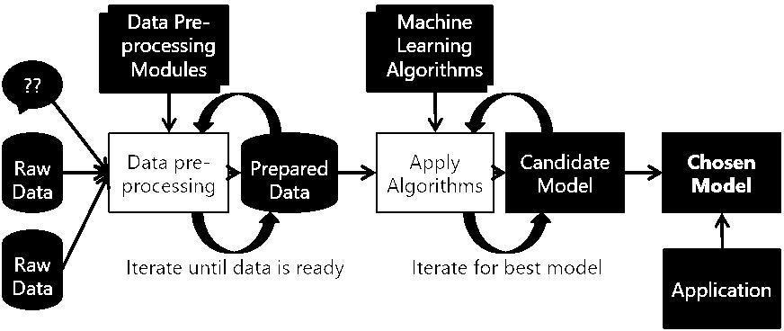
Fig 1.1-Machine learning process

The inputs to our algorithms are
      - Installs
      - Category
      - Free
      - Rating Count
      - Content Rating
The output is a prediction of the rating of the Google Play Store application that is probably going to have happened. We evaluate various calculations, such as Support Vector Machine and Random Forests.

Our Dataset
Kaggle’s website contains the dataset which is utilized by us which is from the steam platform.
However, the dataset has numerous invalid qualities, and to perform Machine Learning this information can't be utilized all things considered. Subsequently, the information should be prepared

Features of this dataset
      - App Name
      - App Id
      - Developer Website
      - Developer Email
      - Privacy Policy
      - Currency
      - Minimum Installs
      - In App Purchases
      - Size
      - Editor’s choice
      - Released
      - Last Updated
      - Ad Supported
      - Maximum Installs
      - Developer Id
      - Price
      - Scraped Time
      - Minimum Android

Preprocessing
Before we create the modules, we need to remove unwanted data from the data which we collected, and then we build the model.

- Importing required libraries:
We, have imported NumPy, pandas, seaborn, sklearn, and matplotlib libraries.
- Importing the dataset:
The downloaded Kaggle dataset has been imported.
- Data cleaning:
Filling the null values and removing unwanted data.

Table 1.2: Dataset after Preprocessing
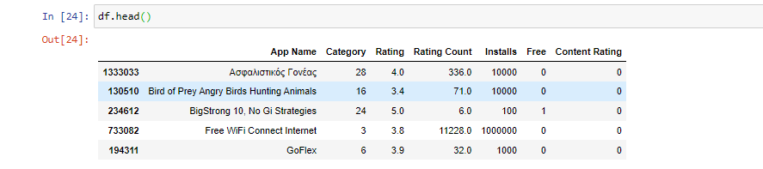

Methodology

The methodology may be known to range from a primarily quantitative approach to a primarily qualitative approach. Information preprocessing is a process of performing crude information and making it accurate for a Machine Learning algorithm.

    - While a Machine Learning Model is building, it isn't constantly a case that we perform all and designed information. And keeping in view that performing any activity with information, it is required to preprocess it and put it in an arranged format. So, for this, we perform data preprocessing task

- Support Vector Model
- Random Forest Model

Role and Responsibilities

Role | Name | Responsibilities
Data Entry | Manuka Varun Teja | ∙ | Data Entry
Data Entry | Manuka Varun Teja | ∙ | Data Preprocessing
& Tester | Manuka Varun Teja | ∙ | Data Preprocessing
& Tester | Manuka Varun Teja | ∙ | Testing
Data Entry | M S Kushal Raj | ∙ | Data Entry
Data Entry | M S Kushal Raj | ∙ | Data Preprocessing
& Tester | M S Kushal Raj | ∙ | Data Preprocessing
& Tester | M S Kushal Raj | ∙ | Testing
 | M Sai Kiran | ∙ | Data Entry
 | M Sai Kiran | ∙ | Data Preprocessing
Data | M Sai Kiran | ∙ | GUI
Data | M Sai Kiran | ∙ | Documentation
Scientist | M Sai Kiran | ∙ | Documentation
Scientist | M Sai Kiran | ∙ | Machine Learning
& GUI | M Sai Kiran | ∙ | Machine Learning
& GUI | M Sai Kiran | ∙ | Data Analysis
Developer | M Sai Kiran | ∙ | Data Analysis
Developer | M Sai Kiran | ∙ | Data Mining
 | M Sai Kiran | ∙ | Data Visualization
 |  | ∙ | Data Entry
 |  | ∙ | Data Preprocessing
Data |  | ∙ | GUI
Data |  | ∙ | Documentation
Scientist |  | ∙ | Documentation
Scientist |  | ∙ | Machine Learning
& GUI | P V S Karthikeya | ∙ | Machine Learning
& GUI | P V S Karthikeya | ∙ | Data Analysis
Developer |  | ∙ | Data Analysis
Developer |  | ∙ | Data Mining
 |  | ∙ | Data Visualization

Contribution of Project
Market potential
There has been a relentless growth among the general public and private information unbroken on the net. This includes matter information expressing people's opinions on review sites, forums, blogs, and different social media platforms. Review-based prediction systems allow this unstructured data to be mechanically reworked into structured information reflective of popular opinion. This structured information may be used after a life of users' sentiments relating to specific applications, products, services, and brands. they'll thence offer necessary data for product and repair refinement. this sort of sentiment analysis was conducted in the following studies. Kumari and alternative researchers used the Naïve mathematician (NB) classifier to classify opinions as positive, negative, or neutral- Wang et al. argued that a rating isn't entirely determined by a review content. for instance, a user may possibly provide a positive review by using positive words and tissue a relatively lower rating- Dave et al. projected a technique for extracting the polarity in user reviews of a product, expressed as poor, mixed, or good. The classifier used was Naïve mathematician (NB).

Information-extraction technology has additionally been explored to spot and organize opinions contained at intervals in the text. As the Associate in Nursing example, some authors planned a theme for the annotation of a low-level illustration of opinions during a text. to boot, they delineate an Associate in Nursing opinion-oriented “scenario template” that summarizes the opinions expressed during a document. This approach is useful for tasks that involve quality the question from multiple views. totally different authors counseled adopting an applied mathematics analysis supported by a spin model, to extract the linguistics orientations of words. Mean-field approximations were accustomed to figuring the approximate likelihood within the spin model. linguistics orientations square measure then evaluated as fascinating or undesirable. A smaller variety of seed words for the planned model end up extraordinarily correct linguistic orientations supported the English lexicon.

Innovativeness
Various sentiment analysis ways are performed to summarize the ensembles of comments and reviews. These ways use mathematical and statistical methods (especially involving Gaussian distributions) to beat the issues encountered in sentiment analysis. Though these authors proposed a model, it was not enforced. A recent study investigated the application of a machine-learning algorithm to a dataset covering, for instance, the app category, the numbers of reviews and downloads, the size, type, and Android version of an app, and the content rating, to predict a Google app ranking. Decision trees, linear regression, logistic regression, support vector machine, NB classifiers, k-means cluster, k-nearest neighbors, and artificial neural networks were studied for that purpose.

App Ratings are expected to support the options provided for the app. Experiments were performed on the BlackBerry World and Samsung golem stores to gather the raw options provided for the apps, together with their value, the rank of downloads, ratings, and matter descriptions. The options were then encoded into a numerical vector to be used in case-based reasoning and to predict the app rating. indistinct from the above-cited studies, alternative authors investigated the character of sentiments expressed in Google app reviews. Their study measured opinions and sentiments portrayed in user reviews through a spread of emojis expressing, for instance, negativity, positivity, anger, or excitement. It evaluated whether or not these sentiments square measure informative for the aim of app development and refinement.

Usefulness
The importance of mobile apps in the lives of today's consumers cannot be overstated. The growth of mobile app advertising has been shown to have a significant impact on cutting-edge innovation. Nevertheless, as the market for mobile apps grows, so does the number of mobile app designers, resulting in a rise in the global mobile app industry's earnings that can only be described as spectacular. In the face of great competition from all over the world, it is essential for a designer to recognize that he is moving in the right direction.

Report Organization
The remaining section of the report is structured as follows:
- Chapter 2 provides detailed business and technical requirements
- Chapter 3 provides analysis and design of this project
- Chapter 4 provides Construction, and implementation details of this project
- Chapter 5 provides the conclusion and future scope as well as future application of this project

Chapter-2

REQUIREMENT ENGINEERING
Functional Requirement
It is an illustration of the service that the software should offer to the user. It defines a software system or its component. A functional requirement is nothing, but they are the inputs to the software system, its behavior, and outputs. The functional requirements describe how an application performs functionally.
A functional requirement is a requirement regarding an output of behavior that shall be provided by a function of the system. Functional Requirements are requirements that specify a function that a system or system component must be able to perform.

Non-Functional Requirement
Non-functional requirements are the inputs to the application which are not directly with specific functionality delivered by the system. The non-functional requirements are mainly about performance, information, economy, management, and security potency and services. They may be also related to different properties such as reliability, usability, etc.

- To provide maximum accuracy:
Accuracy is one of the methods for the evaluation of different models. Accuracy is also known as the fraction of predictions to know whether our model got right or not.

- Provide visualized analysis:
Visual analytics is essentially the combination of data analytics and visualizations. This method of solving problems is regarded as integrating interactive visual representations with underlying analysis processes to effectively facilitate high-level, complex activities, such as reasoning and data-driven decision-making.

- Ease of use:
The extent to that associate application may be utilized by specified users to attain specified goals with effectiveness, efficiency, and satisfaction in a very specified context of use.
- Availability:
Availability is the method to calculate the degree to which the users can depend on the system during operating times.

- Reliability:
It is known as the degree which a product, system, or service will perform its intended function adequately for a certain period of time, or will operate in a defined environment without failure.

- Maintainability:
The degree with which a software application or component can be modified to correct faults, improve performance or other attributes, or adapt to a changing environment

Packages Required:

The following modules are used in our project:

Pandas:
It is an accurate, fast, powerful, flexible, and easy-to-use open-source data analysis and manipulation tool, built on top of the Python programming language.
It is one of the Python libraries.
It is used for the analysis of data.
NumPy:
It is a general array process package. it's a library used for operating with arrays. It additionally has totally different functions for operating in the algebra domain and matrices.
It defines a superior dimensional array object and tools for operating with the arrays. it's the first package for scientific computing in Python.
We have totally different lists that serve the aim of arrays, however, they're slow compared to NumPy to the method.
It provides AN object of array kind that's up to 50x quicker than ancient Python lists.
Matplotlib:
It is a fundamental visualization library in Python for two-dimensional plots of arrays. It is one of the multi-platform data visualization libraries built on NumPy arrays and built to work with the broader SciPy stack.
It is a collection of different functions that make matplotlib work like MATLAB.
Each pyplot function makes some changes to a figure: a, creating a figure, creating a plotting area in a figure, plotting some lines in a plotting area, decorating the plot with labels, etc.

Sklearn:
It is the most useful and secured library for machine learning in Python.
It describes a choice of appropriate tools for machine learning and statistical modeling including different classification, regression, clustering, and dimensionality reduction via a consistence interface in Python.

Seaborn:
Seaborn is one of the Python data visualization libraries based on matplotlib.
It provides a high-level interface for generating attractive and informative statistical graphics
Seaborn is used in exploring and understanding the data.
Its API helps us to focus on what the different elements of plots mean, rather than on the details of how to generate them

Chapter-3

ANALYSIS AND DESIGN
Use case diagram:

Use case diagrams to represent the overall scenario of the system. A scenario is nothing but a sequence of steps describing an interaction between a user and a system.
Thus, a use case is a set of scenarios tied together by some goal. The use case diagrams are drawn for exposing the functionalities of the system.
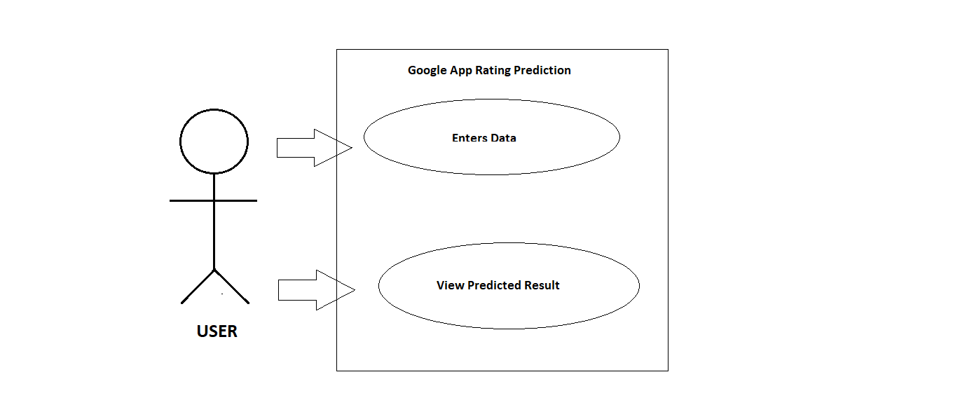

Fig 3.1-Use case diagram

Activity diagram:

The activity diagram may be a graphical illustration for representing the flow of interaction inside specific situations. it's kind of like a flowchart during which varied activities will be performed within the system square measure described

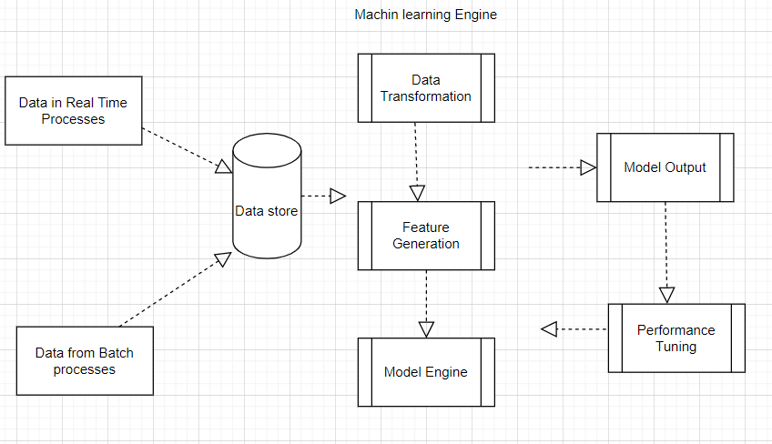

Fig. 3.2. Activity diagram

Sequence diagram:

Sequence diagrams are reticular with use case realizations within the logical read of the system below software system development. it's conjointly referred to as event diagrams or event eventualities.
The sequence diagram shows how the objects interact with each other. There are the steps of events that are represented.

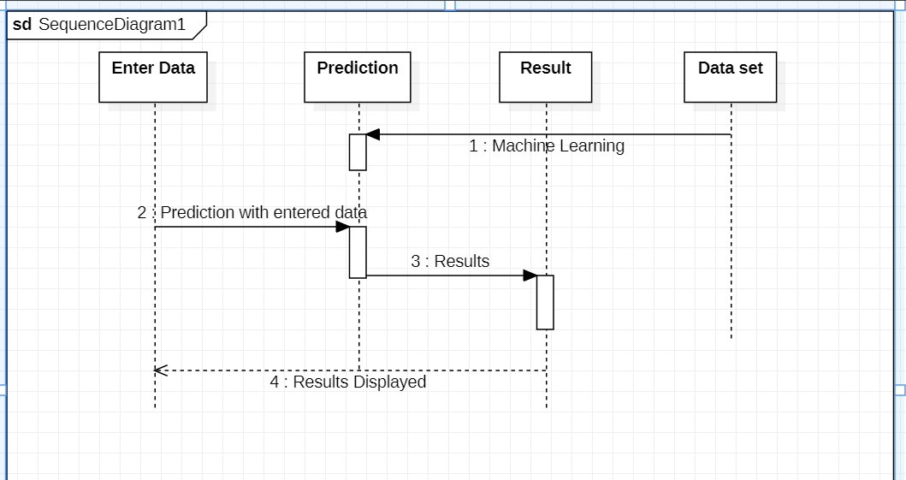

Fig. 3. 3. Sequence diagram

System architecture:

The system architecture will help the designers and engineers in representing a system or application's high-level, overarching layout to ensure the framework addresses the needs of their customers.
The system architectural design is the process of recognizing the subsystems and building up the system and framework for subsystem control and communication. The aim of the system architecture design is to generate the overall structure of the software system.

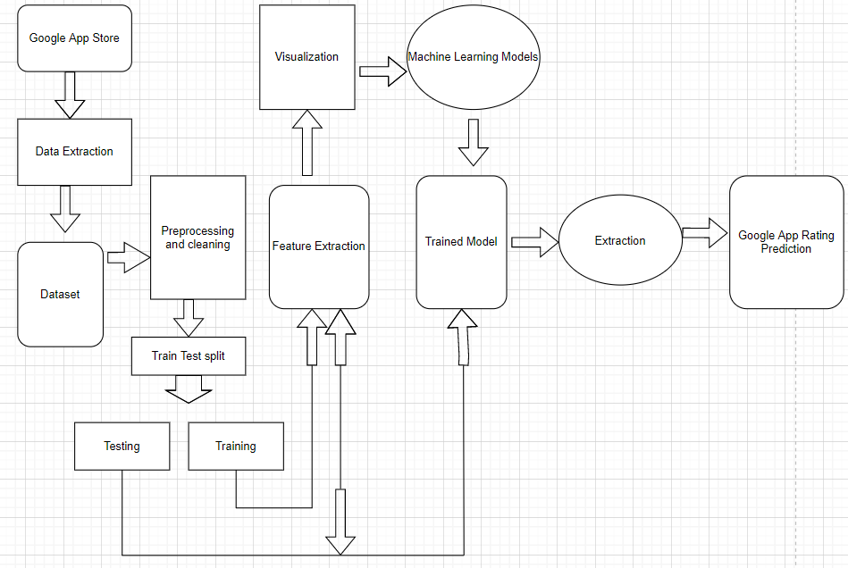

Fig. 3.4. System architecture

Chapter-4
CONSTRUCTION
Implementation

Our project is implemented using python language in a platform called Anaconda. It is used for the building of different Machine learning models.
Anaconda is one of the distributions of Python. Anaconda is one of the new distributions of Python. Continuum Analytics is also the name of Anaconda. Anaconda comprises in excess of 100 new bundles. Anaconda is utilized for various purposes like logical processing, information science, measurable investigation, and ML.
Technology in python is easy to implement in Anaconda because it removes the accompanying tasks:

    - Introducing Python in different stages.
    - Distinguishing out various conditions.
    - Performing such that it does not have the right advantages.

The information is available on the Kaggle website which has datasets which is reliable. Implementation of the idea started from the Problem statement which is given in some random Hackathon for the prediction of app ratings. The data was sorted, the null values are filled and the remaining useless data is dropped for better design of the machine learning project.
The sections were done just to make the Machine Learning model realize what all it has to do with the information and what really the yield will be delivered. When Machine Learning is performed with various calculations and diverse interactions, execution of various calculations is estimated and the calculation which is ideal is utilized for the expectation i.e., Random Forest, Support Vector Machine.

Implementation Details

For the purpose of proper implementation and functioning Algorithms and techniques are used. Following is the algorithm used:

SVM:
Support Vector Machine (SVM) may be a supervised machine learning algorithmic rule used for each classification and regression. tho' we are saying regression issues further it’s best suited to classification. the target of the SVM algorithmic rule is to seek out a hyperplane in AN N-dimensional house that clearly classifies the information points. The dimension of the hyperplane depends upon the number of options. If the quantity of input options is 2, then the hyperplane is simply a line. If the quantity of input options is 3, then the hyperplane becomes a 2-D plane. It becomes troublesome to imagine once the quantity of options exceeds 3. Let’s take into account 2 freelance variables x1, x2, and one variable which is either a blue circle or a red circle.
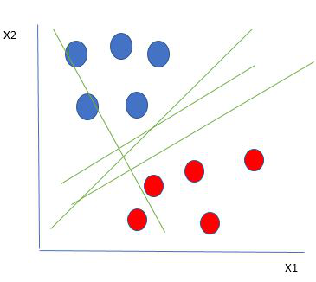
SVM model
From the figure above it’s very clear that there are multiple lines (our hyperplane here is a line because we are considering only two input features x1, x2) that segregate our data points or do a classification between red and blue circles. So how do we choose the best line or in general the best hyperplane that segregates our data points.

RANDOM FOREST:
Random Forest is a popular machine learning algorithmic rule that belongs to the supervised learning technique. It will be used for each Classification and Regression issue in ML. It’s supported the thought of ensemble learning, which could be a method of mixing multiple classifiers to resolve a posh drawback and to boost the performance of the model. As the name suggests, "Random Forest could be a classifier that contains a variety of decision trees on varied subsets of the given dataset and takes the average to boost the prognosticative accuracy of that dataset." Rather than hoping on one decision tree, the random forest takes the prediction from every tree and based on the bulk votes of predictions, indicates the ultimate output. The larger variety of trees within the forest ends up in higher accuracy and prevents the matter of overfitting.
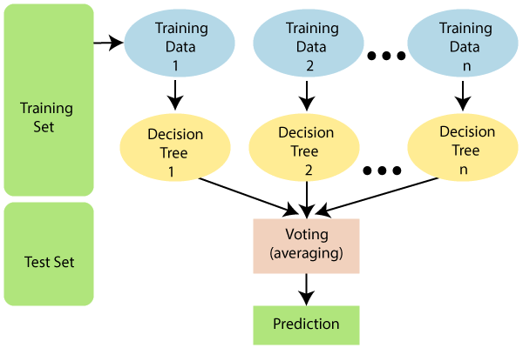
Random forest model
Since the random forest combines multiple trees to predict the category of the dataset, it's attainable that some call trees might predict the proper output, whereas others might not. however along, all the trees predict the proper output. Therefore, below are 2 assumptions for a far better Random Forest classifier:
There ought to be some actual values within the feature variable of the dataset so the classifier will predict correct results instead of a guessed result.
The predictions from every tree should have terribly low correlations.
Random Forest works in two-phase 1st is to form the random forest by combining N call trees, and also the second is to create predictions for every tree created within the 1st section.
The operating method is often explained within the below steps:
Step 1: Build the Support vector regressor model.
Step 2: Build the Random Forest Regressor.
Step 3: Predict the rating victimization of each model.
Step 4: Calculate the typical of each of the models.
Step 6: Our model is finished.

Data Visualization
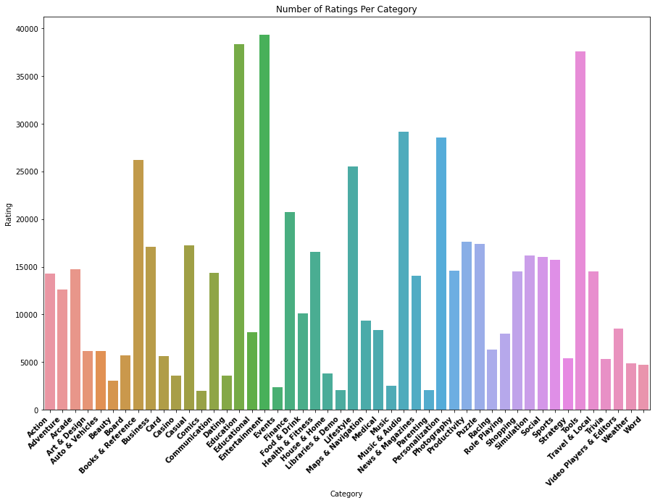

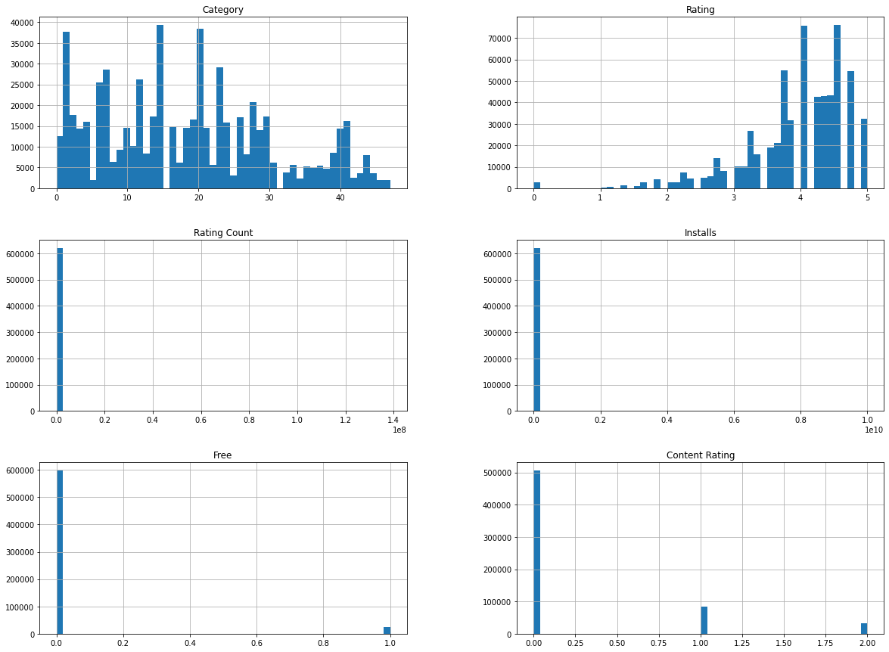
Software Details

    - Anaconda Distribution (v5.1)
    - Python (3.6.5)
    - Jupyter Notebook

Hardware Details

    - Operating system: Windows 7 or newer, 64-bit macOS 10.9+, or Linux.

    - System architecture: 64-bit x86, 32-bit x86 with Windows or Linux.

    - CPU: Intel Core 2 Quad CPU Q6600 @ 2.40GHz or greater.

    - RAM: 4 GB or greater.

Testing

software checking is AN examination to relinquish the partner’s knowledge regarding the character of the merchandise item or administration beneath the test. software package testing will likewise provide a target, autonomous perspective on the merchandise to allow the business to acknowledge and comprehend the risks of programming execution. check methods incorporate the approach toward the death penalty a program or application with the set up of discovering programming bugs (mistakes or totally different deformities) and checking that the merchandise item is suited for use.

Programming testing includes the execution of a product part or framework segment to assess at least one property of intrigue. When all is said in done, these properties demonstrate the degree to which the segment or framework is under test:

- meets the prerequisites that guided its structure and advancement,

- reacts effectively to a wide range of sources of info,

- plays out its capacities inside an adequate time,

- it is adequately usable,

- can be introduced and run in its expected surroundings, and

- accomplishes the general outcome its partners want.

As the quantity of potential tests for even basic programming parts is basically limitless, all product testing utilizes some methodology to choose tests that are achievable for the accessible time and assets. Therefore, programming testing ordinarily (yet not only) endeavors to execute a program or application with the expectation of discovering programming bugs (mistakes or different imperfections). The activity of testing is an iterative procedure as when one bug is fixed, it can light up other, more profound bugs, or can even make new ones.

White box testing

White-box testing is a strategy for programming testing that tests the inner structures or operations of an application, instead of its usefulness (for example discovery testing). In white-box testing an inner point of view of the framework, just as programming abilities, are utilized for configuration experiments. The analyzer picks contributions to practice ways through the code and decides the normal yields.

Black box testing

This is designed to uncover the error in functional requirements without regard to the internal working of the project. This testing focuses on the information domain of the project deriving the test case by partitioning the input and output domain of programming – A manner that provides thorough test coverage.

Proposed Modules and their Functionality:

- 1.IMPORTING REQUIRED LIBRARIES:
we have imported NumPy, pandas, sklearn, matplotlib libraries.

- 2.IMPORTING THE DATASET:
downloaded Kaggle dataset has been imported.

- 3.DATA CLEANING:
filling the null values and removing unwanted data.

- 4. BUILDING SUPPORT VECTOR REGRESSION MODEL:
training the support vector regression model using train data set.

- 5. BUILDING RANDOM FOREST MODEL:
training the random forest model using train data set.

- 6. FETCHING THE TEST DATA:
Visualising the results predicted by the models.

- 7. ACCURACY CALCULATION:
we can find the actual and predicted values by using existing methods called RMSE, r^2, and MAE.

- 8. PREDICT ON DATA FEATURES:
Results of Random Forest and support vector regression algorithms, we collect the outputs and find the averages for better accuracy.

IMPLEMENTATION:

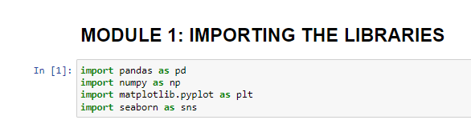
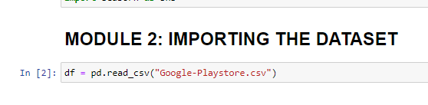
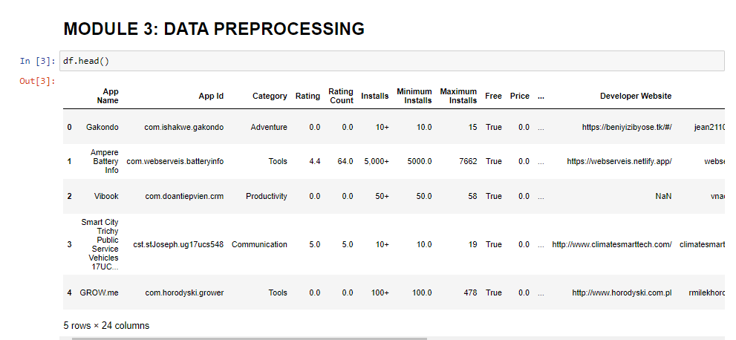
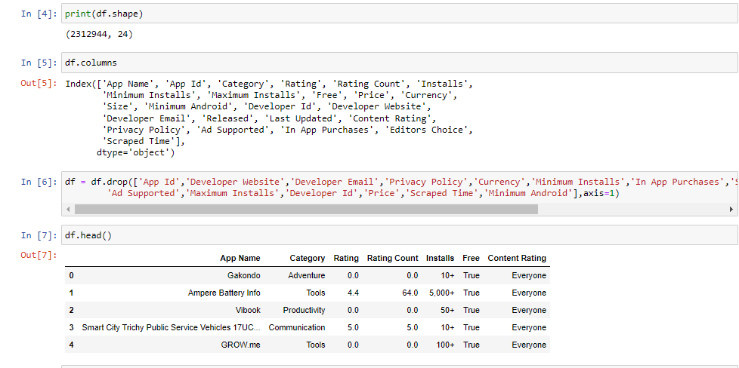

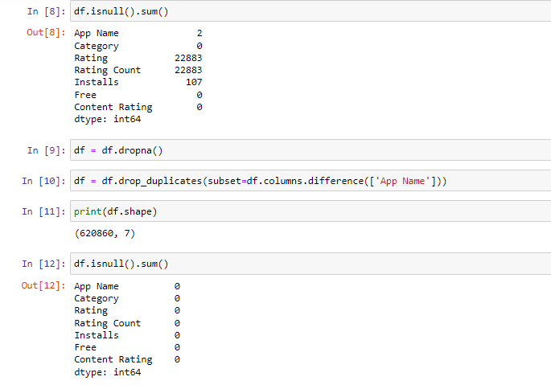
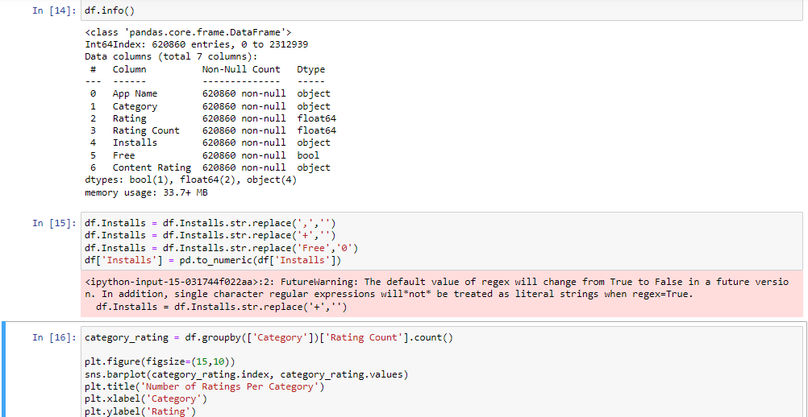

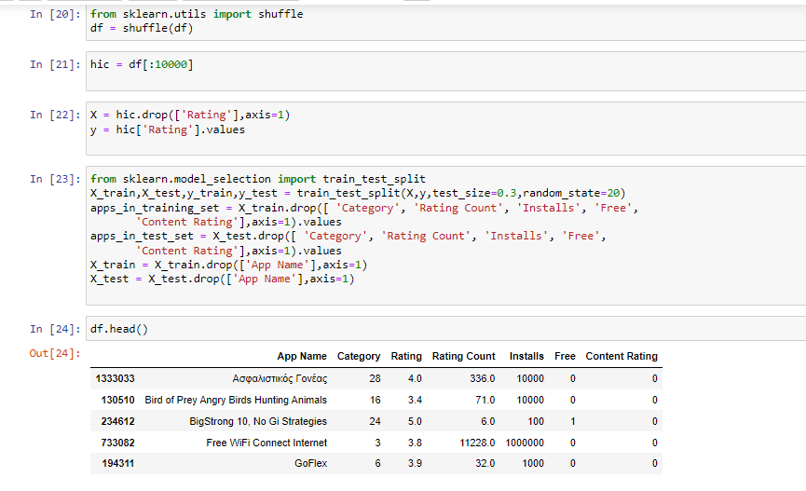
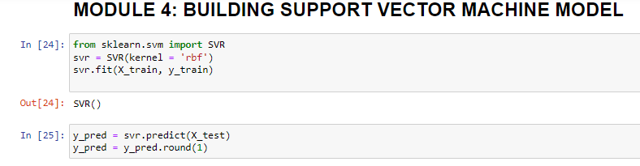
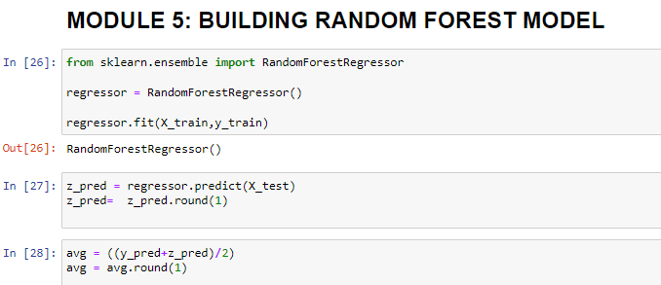

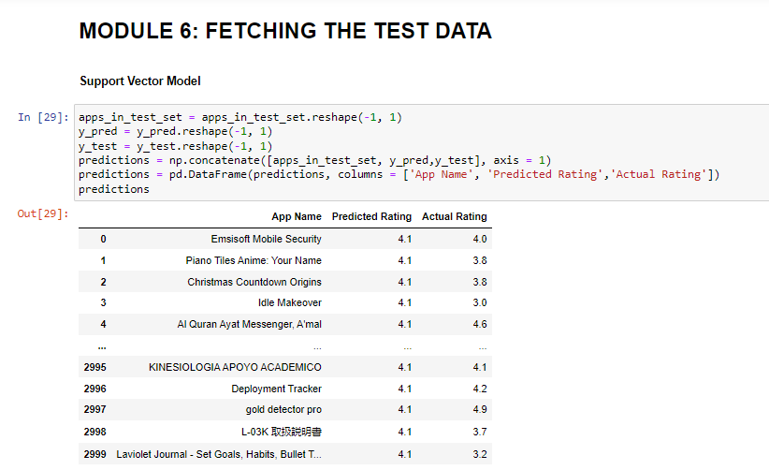
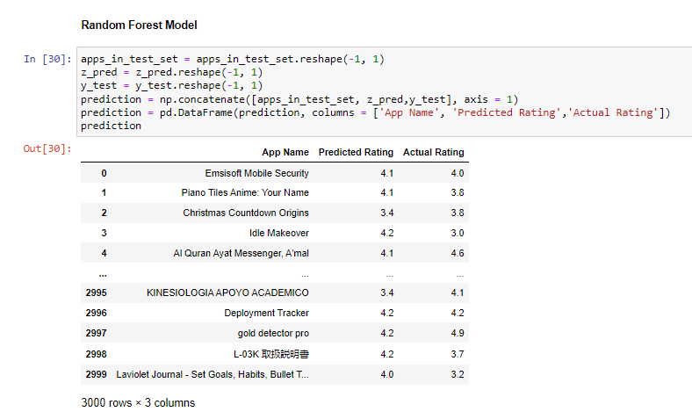

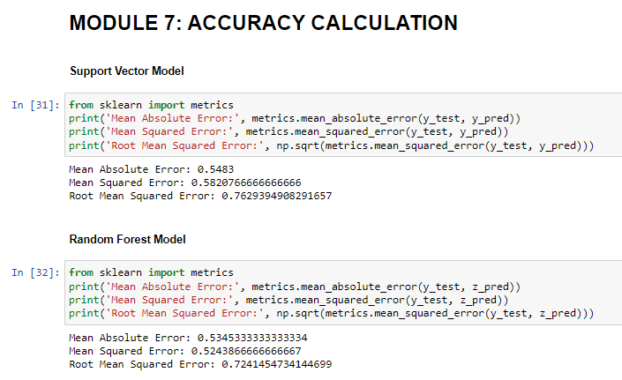
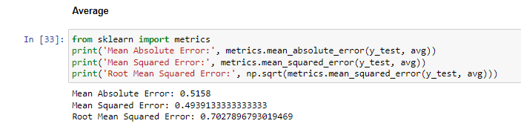
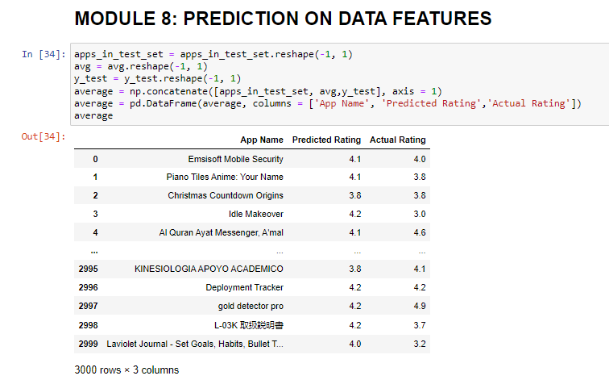

Chapter-5
CONCLUSION AND FUTURE SCOPE

Conclusion
We came to the conclusion that our hypothesis is correct after running through all of these algorithms and processes. As a result, it is possible to predict app ratings, but a large amount of preprocessing is required before the classification and regression processes can be started. The data collected from Google Play Store apps have huge potential to help app development companies succeed. Developers can use the information to their advantage to work on and conquer the Android market! In order to accurately estimate whether an app will have more than 100,000 downloads and be a success on the Google Play Store, we need to know the app's Size, Type, Price, Content Rating, and Genre.

Future Scope
We came to the conclusion that our hypothesis is correct after running through all of these algorithms and processes. As a result, it is possible to predict app ratings, but a large amount of preprocessing is required before the classification and regression processes can be started. The data collected from Google Play Store apps have huge potential to help app development companies succeed. Developers can use the information to their advantage to work on and conquer the Android market! In order to accurately estimate whether an app will have more than 100,000 downloads and be a success on the Google Play Store, we need to know the app's Size, Type, Price, Content Rating, and Genre.

Results:

Preprocessing can remove null values and duplicates from a reliable dataset.
The dataset is separated into two sections: a training dataset and a testing dataset using the train test split function.
A training dataset is required for the development of machine learning models.
This approach makes use of machine learning models that enable vector regression and random forest regression.
The test data set will be used to train models, which will then be used to make predictions.
Based on the results of the two machine learning approaches, the final projection is calculated.
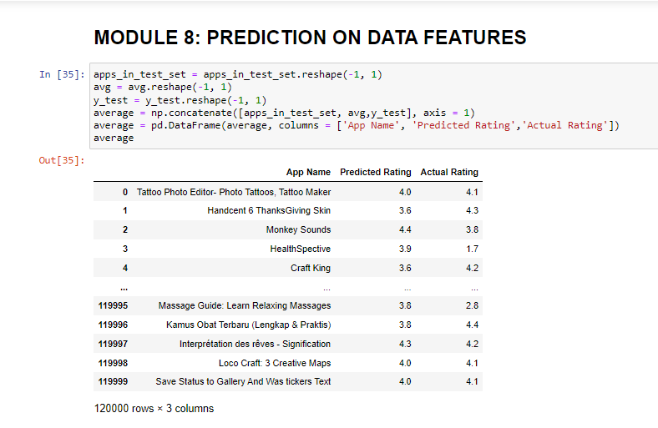
Fig.7: Prediction screen
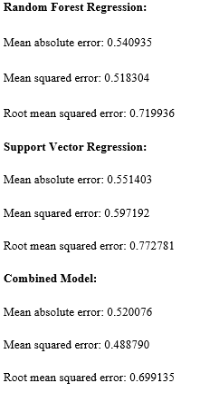

References:

[1] Statista, Number of available application in the Google Play store from December 2009 to March 2019, https://www.statista.com/statistics/266210/numberof-available-applications-in-the-google-play-store/, Online: accessed 22 May 2019.
[2] Statista, Number of mobile app downloads worldwide in 2017, 2018 and 2020 (in billions), https://www.statista.com/statistics/ 271644/worldwide-free-and-paid-mobile-app-storedownloads/, Online: accessed 22 May 2019.
[3] Online shopping, pew internet and American life project, Washington, DC, 2018, http://www.pewinternet.org/Repor ts/2008/OnlineShopping/01-Summary-of-Findings.aspx Online: accessed 8 Aug. 2014.
[4] D. Pagano and W. Maalej, User feedback in the appstore: an empirical study, in Proc. IEEE Int. Requirements Eng. Conf. (Rio de Janeiro, Brazil), July 2013, pp. 125–134.
[5] T. Chumwatana, Using sentiment analysis technique for analyzing Thai customer satisfaction from social media, 2015.
[6] T. Thiviya et al., Mobile apps'feature extraction based on user reviews using machine learning, 2019.
[7] H. Hanyang et al., Studying the consistency of star ratings and reviews of popular free hybrid android and ios apps, Empirical Softw. Eng. 24 (2019), no. 7, 7–32.
[8] N. Kumari and S. Narayan Singh, Sentiment analysis on e-commerce application by using opinion mining, in Proc. Int. Conf.- Cloud Syst. Big Data Eng. (Noida, India), Jan. 2016, pp. 320–325.
[9] R. M. Duwairi and I. Qarqaz, Arabic sentiment analysis using supervised classification, in Proc. Int. Conf. Future Internet Things Cloud (Barcelona, Spain),Aug. 2014, pp. 579–583.
[10] H. S. Le, T. V. Le, and T. V. Pham, Aspect analysis for opinion mining of vietnamese text, in Proc. Int. Conf. Adv. Comput. Applicat. (Ho Chi Minh, Vietnam), Nov. 2015, pp. 118–123.
[11] H. Wang, L. Yue, and C. Zhai, Latent aspect rating analysis on review text data: a rating regression approach, in Proc. ACM SIGKDD Int. Conf. Knowledge Discovery Data Mining (Washington, D.C., USA), July 2010, pp. 783–792.
[12] K. Dave, S. Lawrence, and D. M. Pennock, Mining the peanut gallery: Opinion extraction and semantic classification of product reviews, in Proc. Int. Conf. World Wide Web (New York, USA), 2003, pp. 519–528.
[13] B. Pang, L. Lee, S. Vaithyanathan, Thumbs up?: sentiment classification using machine learning techniques, in Proc. ACL-02 Conf. Empirical MethodsNatural Language Process. (Stroudsbrug, PA, USA), 2002, pp. 79–86.

